Safety Device

Components
- Xiao esp32c3
- A push button
The block diagram
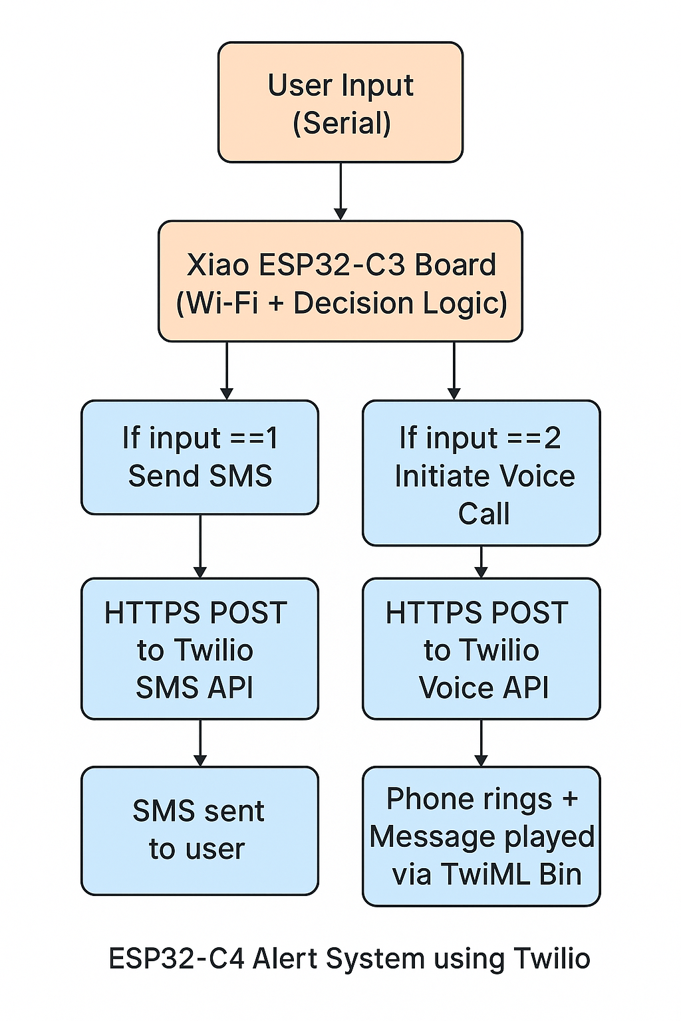

The circuit diagram:
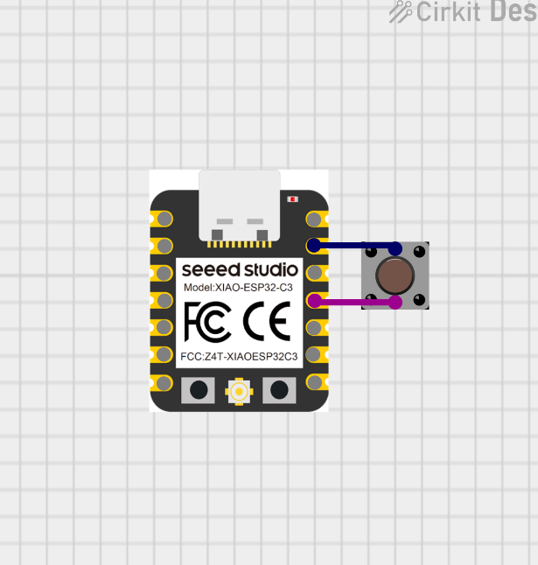

Prototype 2

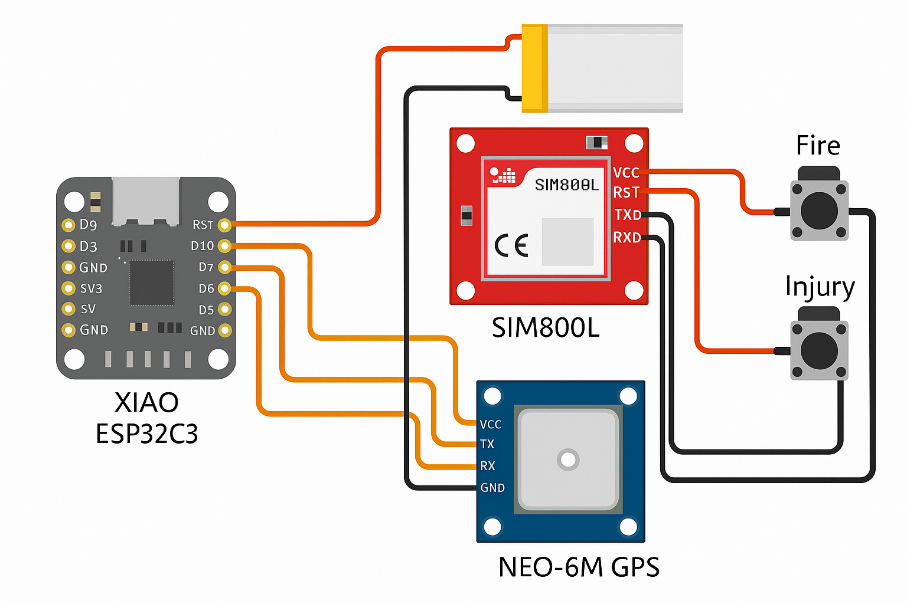

Components
Push button – 2
Xiao Esp32c3
Resister 10 k ohm -2
SIM800L
Working:

Code
#include <SoftwareSerial.h>
#include <TinyGPS++.h>

// GSM module
SoftwareSerial sim800(8, 9); // SIM800L RX, TX

// GPS module
SoftwareSerial gpsSerial(6, -1); // GPS TX → GPIO 6, RX unused
TinySPlus gps;

const int fireBtnPin = 2;
const int injuryBtnPin = 3;

bool fireSent = false;
bool injurySent = false;

String gpsLocation = "Waiting for GPS fix...";
const char* phoneNumber = "+1234567890"; // 🔁 Replace with your real number

void setup() {
pinMode(fireBtnPin, INPUT_PULLUP);
pinMode(injuryBtnPin, INPUT_PULLUP);

Serial.begin(115200);
sim800.begin(9600);
gpsSerial.begin(9600);

delay(1000);
sendAT("AT");
sendAT("AT+CMGF=1"); // Text SMS mode
}

void loop() {
updateGPS();

if (digitalRead(fireBtnPin) == LOW) {
delay(300); // Debounce
if (!fireSent) {
sendSMS("🔥 FIRE ALERT! Location: " + gpsLocation);
fireSent = true;
} else {
makeCall();
delay(10000);
hangUp();
}
}

if (digitalRead(injuryBtnPin) == LOW) {
delay(300); // Debounce
if (!injurySent) {
sendSMS("🩸 INJURY ALERT! Location: " + gpsLocation);
injurySent = true;
} else {
makeCall();
delay(10000);
hangUp();
}
}
}

void updateGPS() {
while (gpsSerial.available()) {
gps.encode(gpsSerial.read());
}

if (gps.location.isUpdated()) {
gpsLocation = "Lat: " + String(gps.location.lat(), 6) +
", Lon: " + String(gps.location.lng(), 6);
}
}

void sendSMS(String msg) {
sim800.println("AT+CMGS=\"" + String(phoneNumber) + "\"");
delay(1000);
sim800.print(msg);
delay(500);
sim800.write(26); // Ctrl+Z
Serial.println("SMS Sent: " + msg);
delay(3000);
}

void makeCall() {
sim800.println("ATD" + String(phoneNumber) + ";");
Serial.println("Calling " + String(phoneNumber));
}

void hangUp() {
sim800.println("ATH");
Serial.println("Call ended");
}

void sendAT(String cmd) {
sim800.println(cmd);
delay(500);
while (sim800.available()) {
Serial.write(sim800.read());
}
}

